AP Studio Art: 2D and Drawing Portfolio Summer Assignments
Welcome!.... your AP portfolio begins now!
Instructions: Your summer homework assignment has four parts; complete all parts and be prepared to submit them during the first week of class in August as well as participate in an oral critique about these experiences. Be advised that these summer assignments are worth a total of 450pts total.

1. Research artists (50pts) In order to create proposed designs for your concentration you will read about and consider 2D Visual artists whose work you identify with.

2. Work in a personal sketchbook/visual journal/altered book. (50 pts)

3. Complete Three or more 18” X 24” drawings based on topics listed. (100pts each)
Compositions previously completed in class do not count.

4. Visit the AP College Board website to look at other AP studio art portfolios and write a reflection about your observations. Follow this link http://apcentral.collegeboard.com and go to the AP Studio Art: 2-D Design Course Home Page. (50pts)

Materials: sketchbook (8x10 or larger), 18X24 sketchpad of multi-color drawing paper(18x24), Drawing pencils, erasers, spray fixative or hairspray. Drawing media to include pastels, pen and Ink,sharpies. Optional (charcoal pencils, white charcoal).

Things to remember:
Plan the negative spaces. Do not let the negative spaces dominate the composition. One way to avoid this is to break up the background (have a cloth supported vertically, a window with curtains, a lamp, candle, or a corner of the room behind the still life). Remember to note value changes behind the objects. If there is strong light on the object, the area behind it will be darker through back shading. Use what you know about the rule of thirds. THERE ARE NO OUTLINES IN A REALISTIC RENDERING. Don’t forget that value against value creates a line. NO BORING FLAT HORIZONTAL LINE FOR THE BACK OF THE TABLE AGAINST A BORING BACKGOUND WALL.

Design the placement of the objects with the size of your paper in mind. It is easiest to draw life size. An asymmetrical composition is generally more interesting. Instead, set up a cloth draped in the background or a lamp casting interesting shadows over an irregular surface such as a curtain.

Mix and blend the colors until you have it right. Box colors don’t look sophisticated enough. Shadows have color; they are not just gray.

Zoom in, use a view finder, provided for you in your packet.

Be Observant, Draw what you see not what you think you see.

Always plan in your sketchbook

Contacts:
You may contact me at any time during the summer if you have any questions. Be patient as I will be in the process of a move but I am usually pretty quick about it.
kimpiercy@bellsouth.net
IG: Kimmyp76 Twitter: ArtBratt
1. Rendering of a Still life
Goals: Balanced Asymmetrical Composition; Correctly Drawn Forms; Full range of values for gradation

What you draw matters! Include at least 3 objects. Break up the surface plane (table area) by placing a loosely draped cloth under the objects. You may want to increase the complexity of the forms by selecting some transparent or reflective objects such as glass.

Set up a single light source. Use a lamp, candle, or light from one side and above. Use a variety of pencils for a wider range of values– 4H(light), HB, 2B, 4B, 6B and Ebony(dark).You may use a charcoal pencil or black colored pencil for the darkest values, but be careful that you mix the Ebony Pencil with the charcoal or black pencil in transition tones. Optically blend by mixing two different graphite pencils or charcoals in transition areas. Avoid smudging with your fingers, since smudging can make it look accidentally dirty.

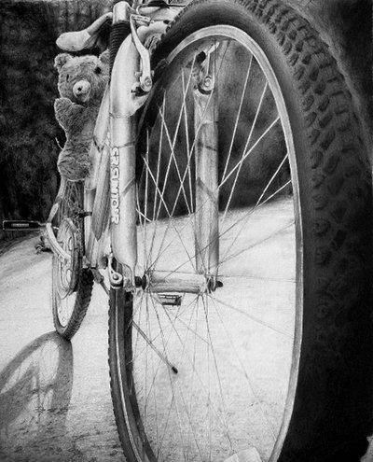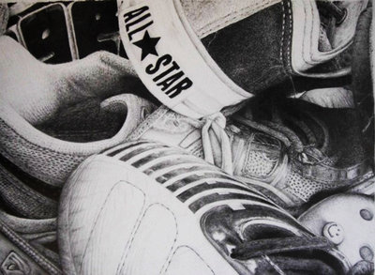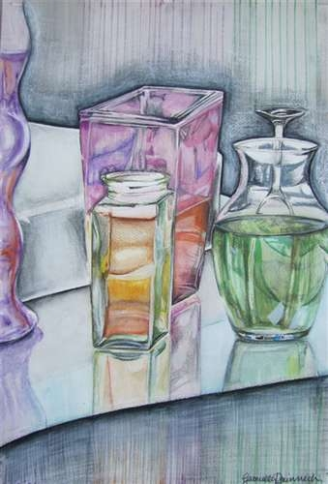

2. Color rendering of many of the same kind of food or object. (Choose any of these media: pencil, chalk, oil pastel on paper, watercolor on watercolor paper, acrylic or oil on canvas)

Consider popcorn, peanuts both in their shells and some broken out of their shells, onions with some cut open, radishes, squash, gourds, ears of corn with some in their shucks and some opened out of their husks, peaches, pasta shells, kiwi fruits, etc. because these have subtle colors. Consider how long you will want your model to hold up when choosing the food. Shrimp are an interesting subject, but after a few days they begin to smell! Enlarge the subject and “zoom in” close so that there is little 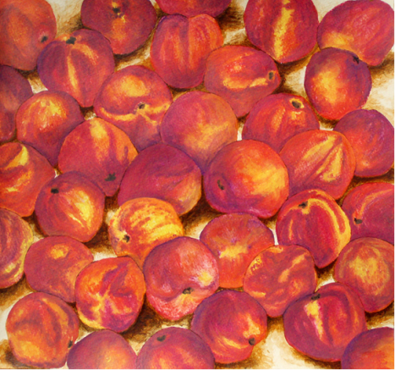 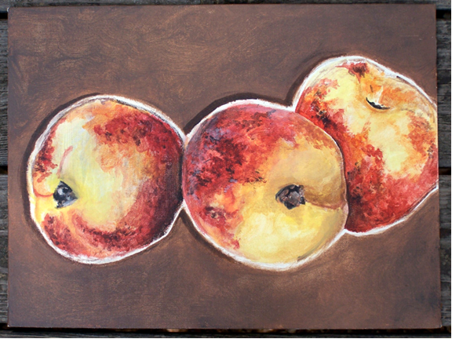 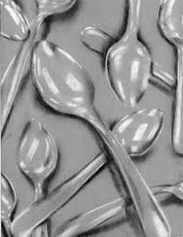

3. Line variation / asymmetrical composition using Ultra-Fine, fine and fat line marker, india ink and quill pen on heavy weight hot press paper
optional: ink wash lines using watercolor brushes.
Goals: Various thicknesses of lines, a dynamic (not static) arrangement of lines at various angles; visual paths of movement; depth of field, and balance of design

Make several rough drafts of ideas. Inspiration may come from a variety of sources—machinery, shells, architecture, maps, topographical maps, old computer circuit boards, pipes and plumbing, etc. Mainly try different compositions. Varying the line thickness can come later. Work with both curved lines and angular lines.

Create a depth of space or depth of field with your line. Some lines may appear to project forward while others recede back into the background. Some of your lines may create the illusion of three-dimensional things. You can also include pattern as a way to address the space as well.

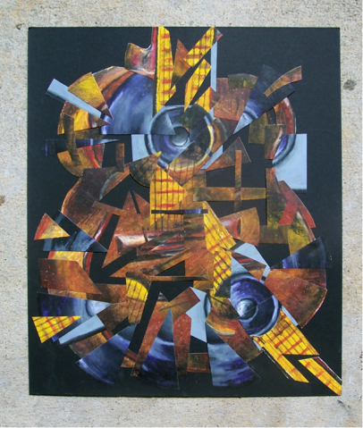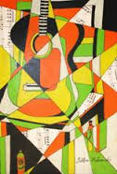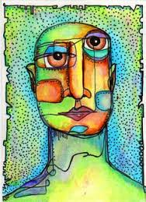

4. Organic (biomorphic) shapes repeated with variation positive / negative space Choose any of these media: ultra fine sharpie marker and large sharpie marker on heavy
Goals: A white complex positive shape that is derived from tree or plant forms (repeated with enough variation for interest) on a black background. You may sometimes flip the positive / negative space. There should be approximately equal amounts of positive and negative space.

Choose an interesting plant such as Venus Flytrap, the large sunflower variety that has lots of seeds for pattern, tomato plants, grape vines with the grapes, blackberry vines with the blackberries, corn stalks with the ears of corn, petunias, day lilies, irises, stargazer daylilies, etc. Do NOT oversimplify because your image may end up looking trite. Fill in the negative areas with marker or black acrylic paint. You may occasionally change or reverse the relationship for more visual interest and balance.

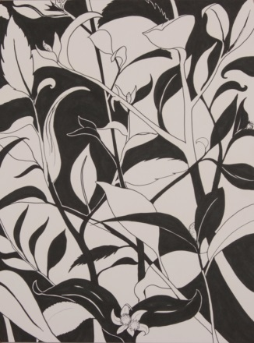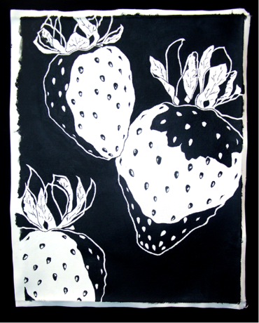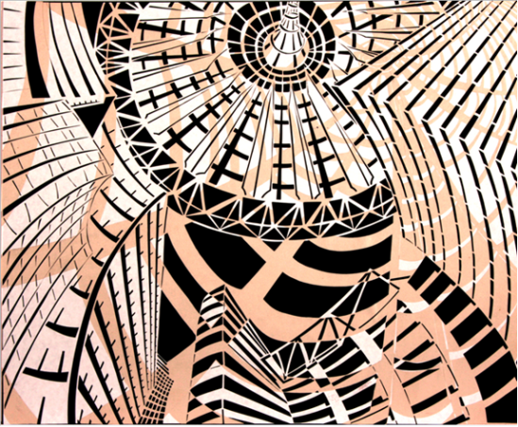

5. Fabric Renduring
Create a drawing, painting or collgae based on fabric. Create your drawing using any of the approved materials on an 18x24 page. It can be a simple cloth or an article of clothing. You may choose to do a stack of clothing or multiple hanging objects. Other objects maybe in the composiotion but the focal poit must be on the fabric.
Goals: A variety of value, depth, movement, repitition, emphasis, positive and negative space, posible texture.

Create depth with a variety of values. These images are rendured particularly well with charcoal (black and white).

Use what you have learned about rull of thirds, use a direct light source byshutting off all lights except a lamp or candle.
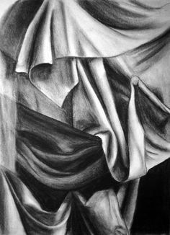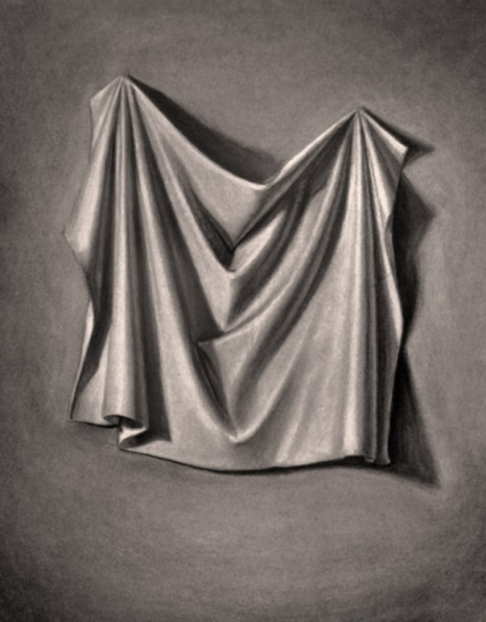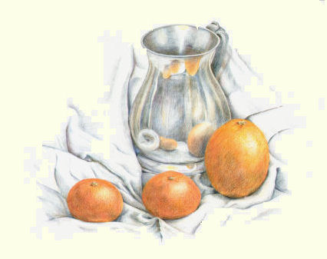

6. One Point Perspective of an Interior Room
Create an image of a one point perspective room. Include at least 10 objects in one point perspective. Make sure you include a variety of value to create the illusion of depth. Think of recreating a room in your house, maybe adding things you wish you had in the room you are drawing or things you with you did not have. Maybe you want to create your dream room. Make sure everything goes back in space to one vanishing point and shade.
Goal: Show the illusion of space using perspective and shading. You may color but make sure you do not make it look like a coloring book.

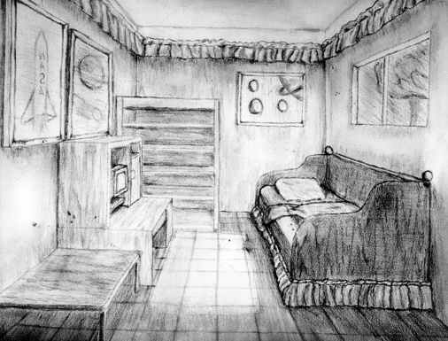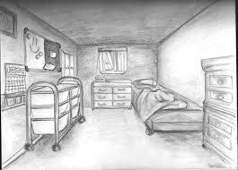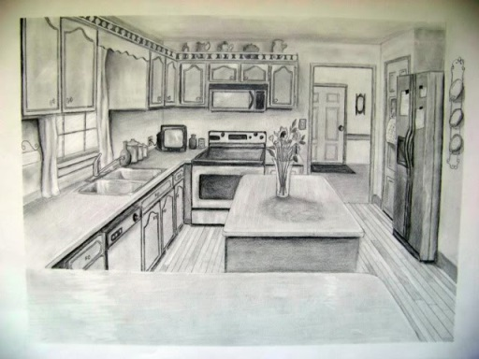

7. Emphasis/contrast
Create a drawing that illustrates contrast or emphasis using color or value. Think about lights and darks, and value as well as complimentary colors or combinations. How can you show emphasis through color or contrast or both in your composition? Make sure you do not forget about the other elements of art as well, they are just as important.
Goal: Illustrate the Principles of Contrast and or emphasis Make sure you consider your environment as well and make good use of your picture plane.

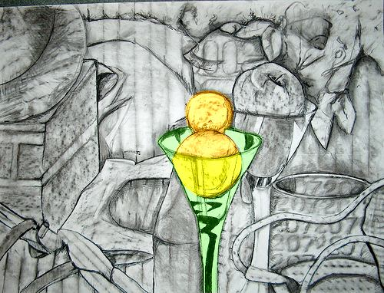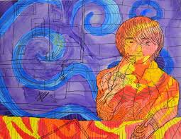

8. Close ups
For this assignment you will choose something ordinary and turn it into something extraordinary! Find something in your environment and zoom in to make it Interesting. Make sure you capture the essence of whatever you are drawing. When you zoom in you have to pay particular attention to detail.
Goal: Illustrate an object in a close-up view to exaggerate detail.
You may choose to add color or a toned background paper. When creating shadows remember that lots of colors are reflecting off of the objects, as well as in the shadows. The best way to create a shadow is by using its compliment.

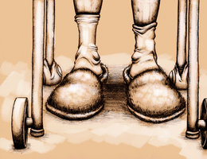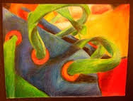

9. Foreshortening
Create an image of foreshortening using your strongest drawing materials. You may also attempt to create a photo using a digital camera in addition to this drawing assignment.
Goal: Capture an image of an object(s) or person illustrating foreshortening. Whatever object is closest to you must be the largest and fill most of the composition plane. Proportions will be very skewed so make sure you use the tools you have learned to create this assignment using accuracy. You will want to illustrate depth of space to the best of your ability. Choose items of people you feel connected to, this will make you feel more connected to your work. Pay close attention to your shading as well. Having a single strong light source will help you in the drawing process.

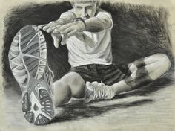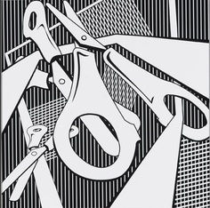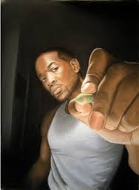

10. Color Theory
Research the various color schemes. Goal: Create an image that demonstrates your knowledge of a particular color scheme or color schemes. For this assignment you may choose to create anything of your original design. You do not have to use the object’s actual color. Think about using color to convey an emotion. Research the Fauvism movement to get ideas.
