Beyond the Art Border
Objective:
Create a 2D mixed media art piece that explores the expansion of the main subject matter that is in the inner rectangle branching into the border around it-going beyond the border. The main subject should remain in color, but everything else turns black & white outside the main boarder.

Directions:
- Choose on your subject matter (suggestions: colorful insects, birds, sea animals-with flowing fins or tentacles)
- In your sketchbook, draw a rough sketch of your design. Place your focal point in the Rule of Thirds.
- When you have your final design approved by me, you may begin on the final paper.
- Start with the outside border, then draw an interior rectangle, or complimentary shape.
- Creatively & selectively expand part of your design onto to the outside border.
- Begin LIGHTLY drawing your interior rectangle. (Suggested to measure 3 1/2” in from each side.)
- Draw your main subject matter in lightly.
- Add your back ground extending ONLY PART of it to the edges of the paper. (Keep it simple)
- Color your main subject with color pencil. (Painters paint your main subject with watercolors.)
- Use a thin sharpie to outline and add details to the subject matter (outline & add details) & to the area beyond the border (this part will ONLY be black & white- can use hatching & cross-hatching, stippling or other Pen & Ink Techniques to show value changes & textures).
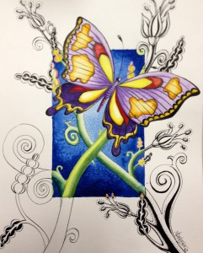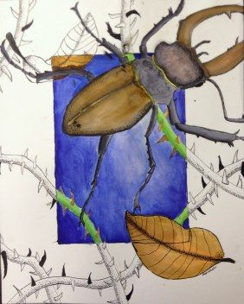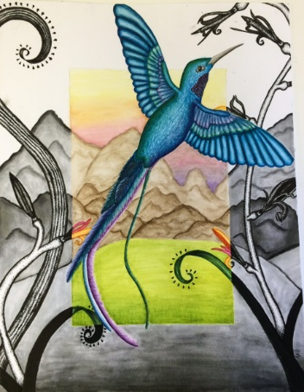
Tips:
Choose a creature that you like and is different.
Draw the image as realistically as you can by looking at a picture of it.
Use bold colors and color smoothly using a cross hatching technique.

How will I be graded? (20pts each)
-Choice and effectiveness of creature
-Balance of background and image
-Composition (Use of space, Elements, Rule of Thirds)
-Use of materials
-Neatness and use of time

Standards:
VAHSDRPR.1
Incorporates elements and principles of design to solve specific visual arts problems and to communicate ideas and emotions, culminating in a finished work of art.
VAHSDRPR.2
Engages in an array of drawing processes and techniques
VAHSDRPR.3
Develops complex art work using a variety of media and technology

