Abacus  At the top of a capital, a thick rectangular slab of stone that serves as the flat, broad surface on which the architrave rests. | 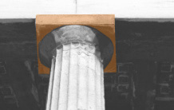
Aedicule  A framing motif consisting of an entablature and pediment supported by two columns. | 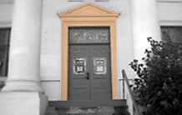
Aisle  A passage or corridor parallel to the nave of a church or an ancient basilica and separated from it by columns or piers. Image courtesy of Gayle Goudy Kochanski | 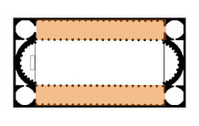
Altar  A table like structure for the celebration of the Sacraments in a Christian building; for sacrifice or offerings in antiquity. | 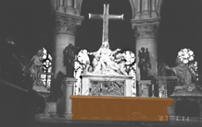
Ambulatory  A semicircular or polygonal passageway around the apse of a church. | 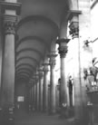
Apse  A semicircular, polygonal, or rectangular extension at the end of a Roman basilica or a Christian church. | 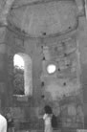
Arcade  A series of arches supported on piers or columns. A "blind" arcade is a row of arches applied to the wall as an ornamental feature. | 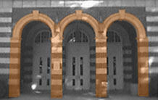
Arch  A structural devise, curved in shape, to span an opening by means of wedge-shaped bricks or stones (voussoirs) that support each other by exerting mutual pressure and that are buttressed at the sides. | 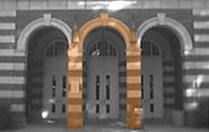
Architrave  A square beam that is the lowest of the three horizontal components of a Classical entablature | 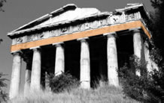
Archivolt  A molded band carried around an arch | 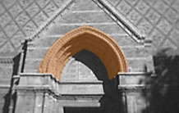
Arcuated  Any form of construction using arches. | 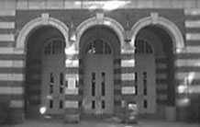
Ashlar  Building stone that has been squared and finished, and the masonry constructed of such blocks. | 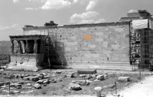
Barrel Vault  A half-cylindrical vault, semicircular or pointed in cross section; also called tunnel vault. | 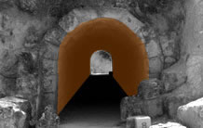
Bay  A vertical compartment of a building in which several such compartments are repeated; each bay mignt be defined by columns, piers, windows, or vaulting units. Michelangelo Museo Capitolino is divided into 7 bays by pilasters. | 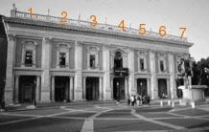
Boss  Sculpted ornament of joints, found primarily in vaults. Image courtesy of Gretchen Ranger | 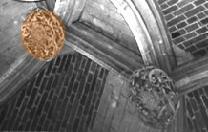
Capital  The uppermost part of a column, usually shaped to articulate the joint with the lintel or arch supported; in Classical types, comprising an abacus, echinus, and other carved detail. | 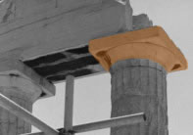
Caryatid  A sculpted female figure used as a support in place of a column or pier. | 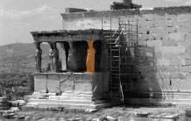
Centering  Temporary wooden framework used to hold construction material in place until a vault or arch is self-sustaining | 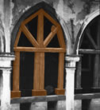
Cloister  An open square court surrounded by a covered ambulatory, often arcaded. It is generally attached to a church or monastery and is distinguished from a secular courtyard by its function as a lace of seclusion and repose. | 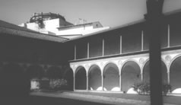
Coffering  Recessed panels, square or polygonal, that ornament a vault, ceiling, or the underside (soffit) of an arch. | 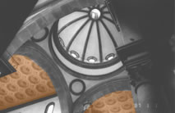
Colonnette  A small or greatly attenuated, slender column. | 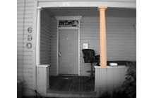
Colossal/Giant Order  Columns or pilasters that rise through several stories; also called a Giant Order. | 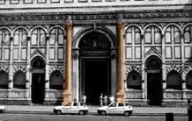
Column  A vertical, usually cylindrical, support, commonly consisting of a base, shaft, and capital; in Classical architecture, its parts are governed by proportional rules. | 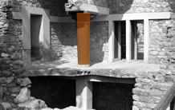
Composite Order  One of the five Classical orders; favored in late Roman architecture. On the capital, large conjoined Ionic volutes are combined with the acanthus leaves of the Corinthian order. | 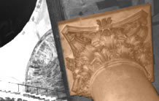
Compound Pier  A pier with columns, shafts, and pilaters attached, sometimes in clusters, to its faces. | 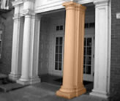
Corbel  A masonry block projecting from a wall to support a superincumbent element. | 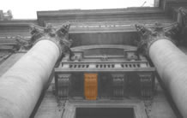
Corbeled Arch  Masonry constructed over a wall opening by a series of courses projecting from each side and stepped progressively further forward until they meet at midpoint; not a true arch. | 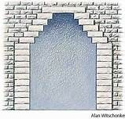
Corinthian Order  The most richly embellished of the three developed by the Greeks, with a tall capital composed of a bell-shaped core enveloped by layers of acanthus leaves. | 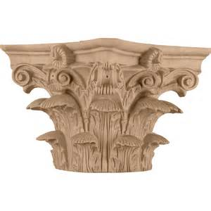
Cornice  The uppermost, projecting portion of an entablature; also the crowing horizontal molding of a building or wall. | 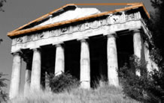
Crossing  The area where the nave and transept intersect in a cruciform church, frequently surmounted by a tower or dome.  (This tower is over the crossing). | 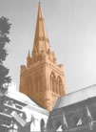

Crypt
A vaulted space beneath the pavement of a church, often housing relics or tombs.
Dome  A curved vault that is erected on a circular base and that is semicircular, pointed, or bulbous in section. | 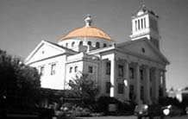
Doric Order  The column and entablature developed on mainland Greece; the fluted columnar shaft is without a base; its capital is an abacus above a simple cushionlike molding (echinus). | 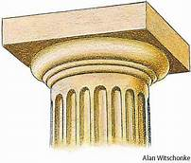

Drum
1. The cylindrical or polygonal wall supporting a dome.
Dry Masonry  Masonry laid without mortar. | 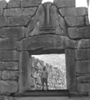
Engaged Column  A column attached to or appearing to be partly embedded wthin a wall. | 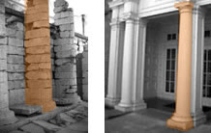
Entablature  The upper part of a Classical order comprising architrave, frieze, and cornice. | 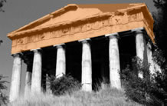
Exedra  A semicircular recess or niche; a large apse. | 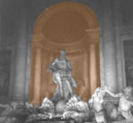
Extrados  The upper surface of an arch or vault. | 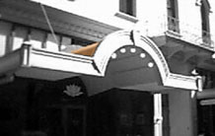
Facade  The principal exterior face of a building, usually the front. | 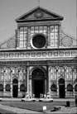
Fluting  The shallow concave channels cut vertically into the shaft of a column or pilaster. In Doric columns, they meet in a sharp edge (arris); in Ionic, Corinthian, and Composite columns, they are separated by a narrow strip. | 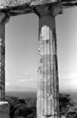
Frieze  A horizontal band, sometimes painted or decorated with sculpture or moldings. It may run along the upper portion of a wall just beneath a cornice or it may be that part of a classical entablature that lies between the architrave and cornice. A Doric frieze often has continuous relief sculpture. | 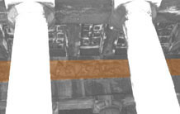
Gable  A triangular element. It may be the end of a pitched roof framed by the sloping sides. It also refers to the top of a Gothic panel, or to the triangular area above the portals of a Gothic building. Image courtesy of Gretchen Ranger | 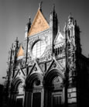
Gallery  An upper story projecting from the interior wall of a building, or placed above the aisles of a church. It may function as a corridor or as an area for assembly or seating. Image courtesy of Gail Gould | 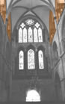
Groin Vault  A vault formed when two barrel vaults of identical size intersect at right angles (also called a cross vault). Image courtesy of Gail Gould | 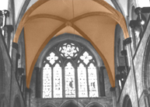
Impost  In a pier, the projecting molding at the springing of an arch. A rectangular impost block transmits the weight of an arch to a supporting member; it may appear between the capital of a column and the springing of an arch. Image courtesy of Gayle Goudy Kochanski | 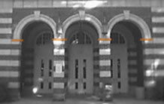
Intrados  The undersurface (as opposed to extrados) of an arch (or vault); also called a soffit. Image courtesy of Gayle Goudy Kochanski | 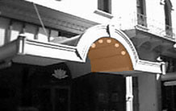
Intercolumnation  The space between adjacent colunms in a colonnade, frequently determined by some multiple of the diameter of the column itself. Image courtesy of Heather Russell | 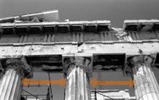
Ionic Order  One of the five Classical Orders, the Ionic is characterized by a scroll-shaped (voluted) capital element, the presence of dentils in the cornice, and a frieze that mighta contain continuous relief ornament. Image courtesy of Gretchen Ranger | 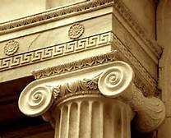
Keystone  The central voussoir at the top of a completed arch. Image courtesy of Gayle Goudy Kochanski | 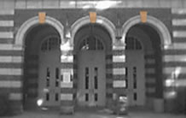
Lancet Window  A tall, slender window with a sharply pointed arch (like a lance), common in early Gothic architecture. Image courtesy of Gretchen Ranger | 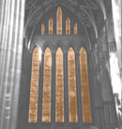
Melon Dome/Umbrella Dome  A dome subdivided into individual concave webs; sometimes called an umbrella dome. Image courtesy of Gretchen Ranger | 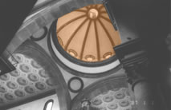
Metope  In the frieze of a Doric order, the rectangular area between tryglyphs; often left plain but sometimes decorated with relief ornament. Image courtesy of Heather Russell | 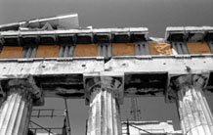
Molding  A sculpted, ornamental band, carved with a distinctive profile or pattern; highly developed in Classical architecture. Image courtesy of Heather Russell | 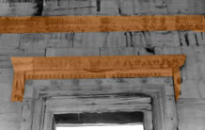
Narthex  A colonnaded porch in front of the facade of a church, in early Chrisian architectue often serving as the fourth side of an atrium; also a transverse vestibule preceding the church nave and aisles. | 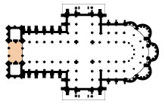
Nave  The central, longitudinal space of a basilican church, separated from the aisles or from side chaples, and extending from the main entrance to the transept or to the apse. | 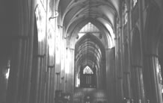
Niche  A concave recess in a wall, often used to house statuary. | 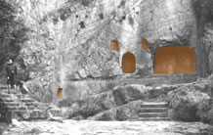
Oculus  A round window. (Commonly found at the top of a dome) | 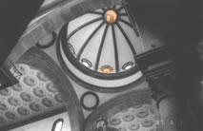
Palladian Motif/Serliana  A triple opening formed by a central semicircular arch springing from the entablature of narrower flanking square-headed bays, used by architect Andrea Palladio. Also known as a Serliana because it was first illustrated in the architecture treatise of 1537 by Sebastiano Serlio. | 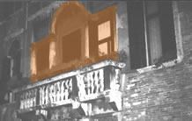
Parapet  A low wall for protection at the edge of a balcony, terrace, roof, bridge, etc | 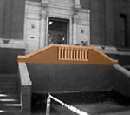
Pedestal  A supporting substructure for a column or statue. | 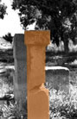
Pediment  A triangular space formed by sloping sides and horizontal cornice of a gabled temple; also used above a door or window | 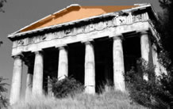
Pendentive  An inverted, concave, triangular piece of masonry serving as the transition from a square support system to the circular base of a dome. | 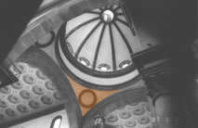
Peripteral  Pertaining to a building surrounded by a row of columns on all sides. | 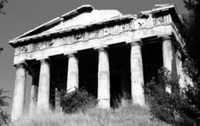
Piano Nobile  The principal reception and living area in an Italian palace, the first floor above the ground. | 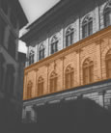
Piazza  The Italian term for a city square. | 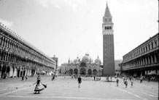
Pier  A massive vertical support often rectangular in plan and therefore differing from a column, sometimes having its own capital and base. When combined with pilasters, columns, or shafts, it is called a compound pier. | 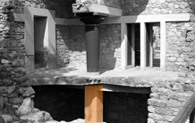
Pilaster  A column is flattened, rectangular shape, projecting slightly form the face of the wall. | 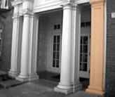
Plinth  A generally square block forming the bottommost element of a column base; or the projecting lowest portion of a wall. | 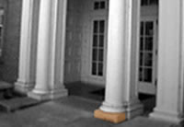
Portico  An open, colonnaded, roofed space serving as a porch before the entrance to a building. | 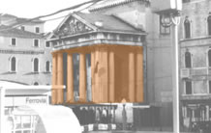
Post and Lintel  A system of construction in which two or more uprights support a horizontal beam; also called trabeated. | 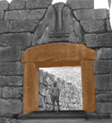
Quoin  Large stone or block laid at the corner of a building (or at an opening) used either for reinforcement of the angle or for ornament. | 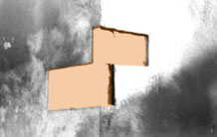
Revetment  The facing of a surface, usually a wall, with stone for ornamentation or protection.  (Notice how the ornamental revetment is only on the facade and does not continue on the side surfaces.) | 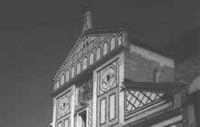
Rib  A slender, projecting arched member of a vault, used to facilitate its construction, reinforce its structure, or articulate its form in varying ways in Roman, Byzantine, and Islamic, Gothic, and Baroque architecture. | 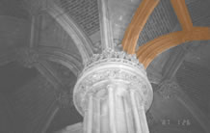
Rib Vault  An arched ceiling or roof supported or reinforced by ribs. Image courtesy of Gretchen Ranger | 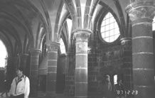
Rustication  Masonry with massive, strongly textured or rough-hew blocks and sharply sunk joints, distinguished form smooth ashlar. | 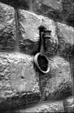
Scotia  A concave molding used as the intermediate part of a base. | 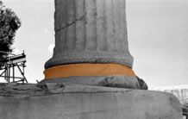
Shaft  The cylindrical body of a column between capital and base. | 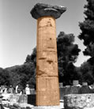
Spandrel  The triangular area between adjoining arches, or the triangular area next to a single arch. | 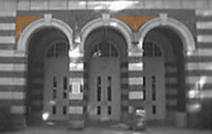

Spire
A tall pointed termination of a tower or roof. Image courtesy of Gretchen Ranger

Splay
The widening of windows, doorways, and other openings by slanting the sides.
Springing  The point from which an arch or vault springs or rises from its supports. Image courtesy of Gayle Goudy Kochanski | 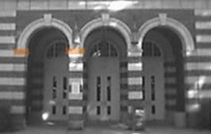
Stringcourse  A continuous, projecting horizontal course of masonry, ususally molded, running along, the surface of a wall, to mark an architectural subdivision. Image courtesy of Gayle Goudy Kochanski | 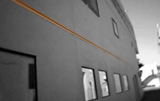
Torus  A large convex molding found principally at the base of a column. | 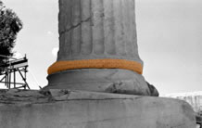
Tracery  Ornamental intersecting stonework in Gothic windows, panels, and screen of Gothic buildings; also used on the surface of late Gothic vaults. Varied techniques and patterns are given names such as plate tracery (built up in corsed layers like the framing walls), bar tracery (constructed of complex fragments of the total pattern), flowing tracery (seemingly freehand, curvilinear design, though compass drawn), etc. | 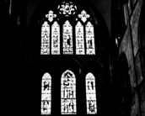

Transept
In a basilican church, the arm that crosses the nave at right angles, usually separating it from the apse; twin transept arms may also project from the nave without interrupting it.
Triglyph  In a Doric frieze, the projecting block marked by vertical grooves (glyphs) between the rectangular areas known as metopes | 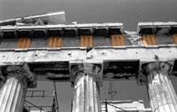
Vault  An arched ceiling or roof made of stone, brick, or concrete (cf. barrel vault, fan vault). | 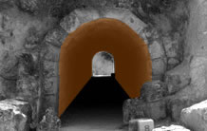
Volute  Ornament in the form of a spiral scroll, and the principal feature of the Ionic capital. | 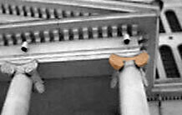
Voussoir  A wedge-shaped stone used in the construction of an arch or vault. | 