Contour line with Emphasis on Color

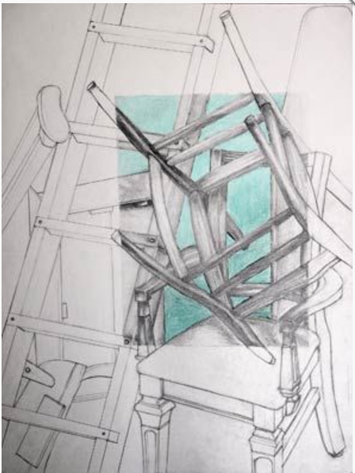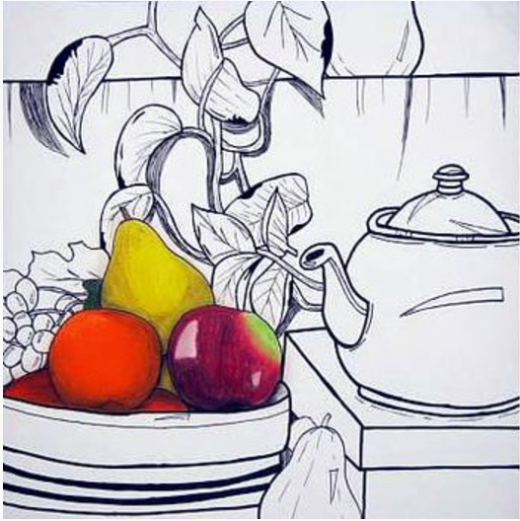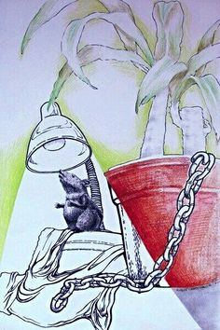

Objective: After learning about contour line, line weight, composition, and color pencil techniques, students will create a contour line composition using color as emphasis.

Steps:
- Find a still life set up you feel comfortable drawing in the room. (You may create your own but it must be approved by your instructor.)
- If you have access to a phone take a picture of your still life in case items move over time.
- Using what you know about composition, draw your image on a 18x24 sheet of paper in contour line form.
- YOU MUST DRAW FROM REALITY.
- Make sure your lines are smooth (not hairy) and you use a variety of line weight.
- After learning about color pencil techniques choose an area of your image to selectively color.

Tips:
- Choose a grouping of items you feel comfortable drawing or slightly above your ability.
- Use a view finder to block out your image.
- Use your cell phone as a reference.
- Draw big and fill up your space
- Go slow and observe!
- When adding color start light and build up your values, use multiple layered colors.
- You may want to go over your lines with sharpie but first ask your instructor for advice.

How will I be graded?
20 points each
I drew a grouping of AT LEAST 5 objects in contour line form
I filled up my paper using very little negative space.
My lines are smooth and I used a variety of line weight
I chose an area to color with color pencils, showing emphasis
My image is neat, clean, presentable, and I made good use of my class time.

