Endangered Animal Water Color
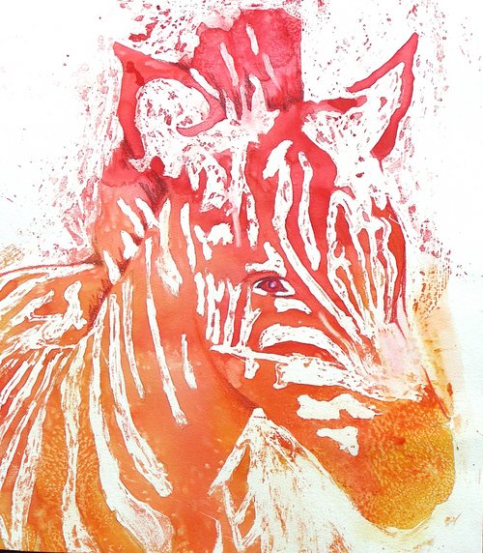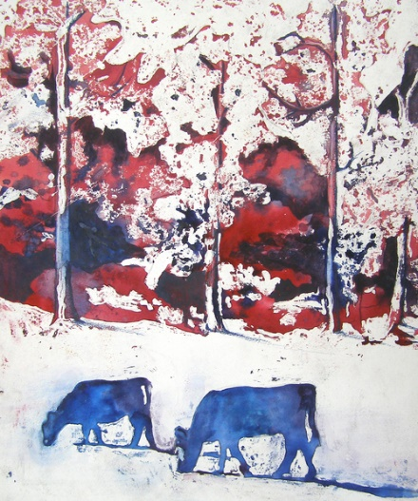

Steps:
- Find an endangered animal that you like.
- Copy and paste it into a word document and blow out the color. (Directions below)
- Draw the animal on watercolor paper LIGHTLY with a pencil
- Mask the white areas using Rubber cement by ‘painting’ them.
- Paint them AT LEAST twice
- Using a color sceme of your choice, piant the entire area in an interesting way
- Let dry
- Peal off Rubber Cement.

How to prepare your image:
- Open word Document
- Set Margins to Narrow
- Select landscape or portrait depending on the orientation of your image.
- Copy and past your image into the document
- Double click on your picture and crop as needed.
- Click on the bottom right hand corner and stretch your image to fit the page
- In the tool bar on the left, click on ‘Color’ and select the black and white image.
- Print your picture

How will I be graded? (20 points each)
You created an interesting composition using compositional rules
Your animal is clearly drawn and recoginzable
You chose an interesting color scheme and it is clear.
You masked the white areas effectively and removed maskign material
Your image is neat, clean and presentable, and you used class time effeciently.

