Illustrated Quote
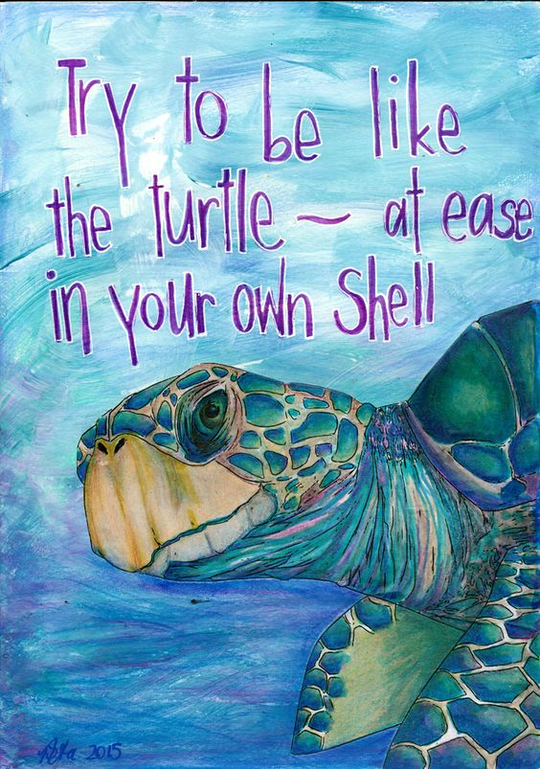
You have been hired to design and illustrate a poster that is based on a positive quote of your choice.

Steps:
- Choose an interesting quote you are drawn to.
- Sketch/plan your idea in your sketchbook.
- Once you have cleared it with your instructor begin drawing your poster lightly in pencil on a sheet of 18x24 paper.
- Add color using at least 2 Mediums.

Tips:
-Choose a quote that you like and makes an image ‘pop’ into your head.
-Use value….. doesn’t have to be a lot but a little value goes a long way.
-Choose colors that enhance your image
-Choose colors that allow the text to be clearly read.
-Look up an interesting font to use as a reference.

How will I be graded?
- The image is creative and illustration clearly relates to the quote. (20pts)
- The text is deliberate, clear, neat, and relevant to the image. (20 pts)
- Artist used AT LEAST 2 art mediums correctly and in a mature way, enhancing image. (20pts)
- Artist used compositional rules and filled up the compositional frame. (20pts)
- Composition is neat, clean and artist used good use of class time. (20pts)

Standards:
VAHSDRMC2
Finds and solves problems through open-ended inquiry, the consideration of multiple options, weighing consequences, and assessing results.
VAHSDRCU1
Articulates ideas and universal themes from diverse cultures of the past and present.
VAHSDRPR1
Incorporates elements and principles of design to solve specific visual arts problems and to communicate ideas and emotions, culminating in a finished work of art.
VAHSDRPR2
Engages in an array of drawing processes and techniques.
VAHSDRPR4
Keeps a visual/verbal sketchbook journal, consistently throughout the course, to collect, develop and preserve ideas in order to produce works of art around themes of personal meaning.

