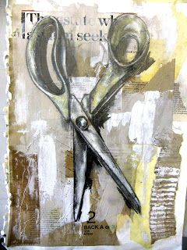
Jim Dine Inspired Tools Triptych

Jim Dine is a modern day pop art artist. He takes everyday items that you recognize and creates a series of images based on those items. Some of them included are hearts, bathrobes, and tools. For this assignment you will create a triptych (series of 3) of the same tool of your choice. Your finished product will consist of 3 mixed media images on cardboard using at least 2 different drawing mediums.

Steps:
- Choose a tool of your choice, take several different pictures of the same tool from different angles using your phone or my iPad.
- Draw it at least once in your sketchbook.
- Prepare your backgrounds using multiple papers and white paint.
- Draw the same tool from 3 different angles on each board. Use at least 2 different mediums.

How will I be graded?
- Following directions
- Creativity (Use of colors, mediums, angles of tool, choice of tool, etc)
- Neatness (Correct use of medium, no folds, fingerprints, tears, etc.)
- Ability to render the tool as correctly as possible (Attention to detail and proportion)
- Composition (Use compositional rules)

Tips:
Push yourself, don’t settle for the ‘quick out’
Experiment in your sketchbook
Don’t be scared to use color
Try something other than pencil
Make your image POP!
Explore your options! Make sure the item you choose looks good from SEVERAL angles.

Standards:
VAHSDRMC.1
Engages in the creative process; imagines new ideas by using mental and visual imagery, conceptualizes these ideas by using artistic language and contextual understandings, and accesses learning. The student develops a personal artistic voice that gives unique form to these concepts.
VAHSDRMC.2
Finds and solves problems through open-ended inquiry, the consideration of multiple options, weighing consequences, and assessing results.
VAHSDRPR.1
Incorporates elements and principles of design to solve specific visual arts problems and to communicate ideas and emotions, culminating in a finished work of art.
VAHSDRPR.2
Engages in an array of drawing processes and techniques

