Pen and ink on watercolor
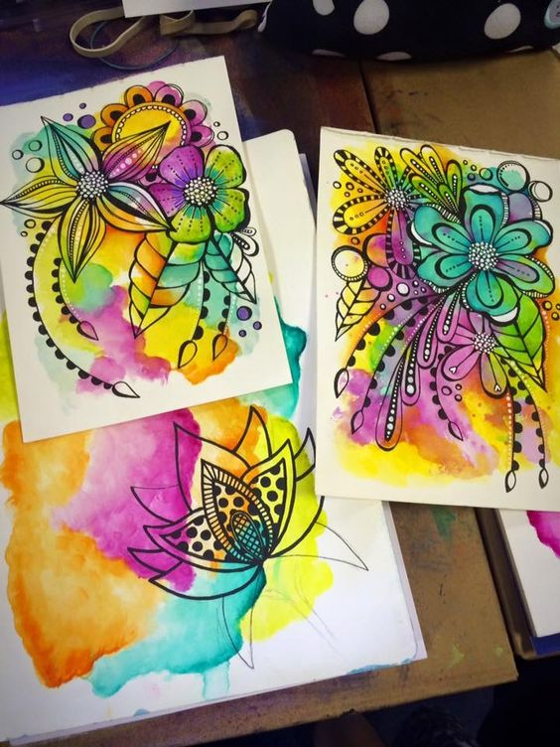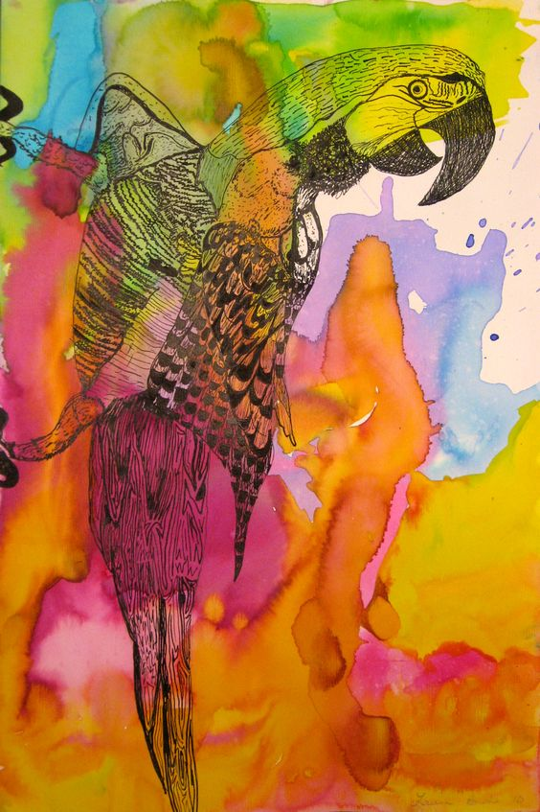
Objective: Create an image on a watercolor back ground using pen and ink.
Steps:
- Decide what kind of interesting image you are going to create. You may choose a zentangle or an animal or something fantasy….. whatever you choose make it interesting and creative.
- On the watercolor page you previously panted draw your composition in pencil.
- Trace over it with a thin black sharpie or pen.
- Selecitvly add more black where needed to give it more interest.

Pen and ink on watercolor
Objective: Create an image on a watercolor back ground using pen and ink.
Steps:
- Decide what kind of interesting image you are going to create. You may choose a zentangle or an animal or something fantasy….. whatever you choose make it interesting and creative.
- On the watercolor page you previously panted draw your composition in pencil.
- Trace over it with a thin black sharpie or pen.
- Selecitvly add more black where needed to give it more interest.

