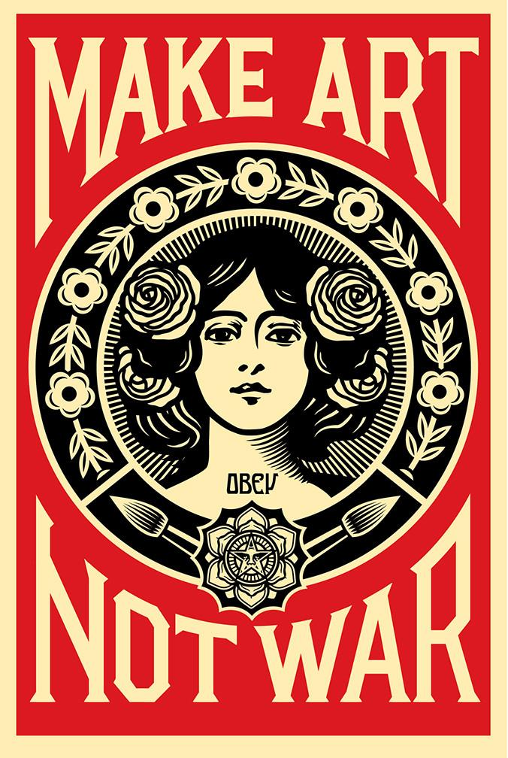

Modern day Propaganda Posters: Making a stand through Art

Propaganda is defined as, information, ideas, or rumors deliberately spread widely to help or harm a person, group, movement, institution, nation, etc. For this assignment you will create your own propaganda poster on a topic you feel strongly about.

Steps:
1. In your sketchbook list causes or movements you feel particularly drawn to.
2. Develop your idea either through a thumbnail sketch or notes
3. On your large 18x24 paper begin to plan your poster using a yard stick.
Make sure you measure and leave room for words and images
4. Using the media of your choice add color to your composition. Make sure your choice of color helps support your message

Tips:
Choose a topic based on Government, Religion, Environment, Education, Current event, Movement, etc.
Choose a medium or mediums you feel comfortable using
Lightly draw your entire image out with pencil before adding color
Use your tools and resources: Stencils, internet, tape, projector, etc.

How will I be graded?
I chose, planned, and illustrated an interesting and RELOVENT modern day topic (20pts)
I created text that was effective, brief, and well-illustrated (20pts)
The image I chose was appropriate and helped to support my statement (20pts)
I colored my image in the media of my choice, making sure my image was neat, clean, and the colors supported my idea (20pts)
My Image is neat, clean, and presentable and I exhibited good use of class time (20pts)

Standards:
VAHSDRPR.1 Incorporates elements and principles of design to solve specific visual arts problems and to communicate ideas and emotions, culminating in a finished work of art.
VAHSDRPR.3 Develops complex art work using a variety of media and technology
VAHSDRCU.1 Articulates ideas and universal themes from diverse cultures of the past and present.
Element: VAHSDRCU.1.a
Identifies how the issues of time, place and culture are reflected in selected art works.
Element: VAHSDRCU.1.b
Compares the ways in which the meaning of a specific work of art has been affected over time because of changes in interpretation and context.
Element: VAHSDRCU.1.c
Discusses how understanding the original context of an artwork affects a viewer’s connection with the interpretation of the artwork.

