Visual Journal Research Project
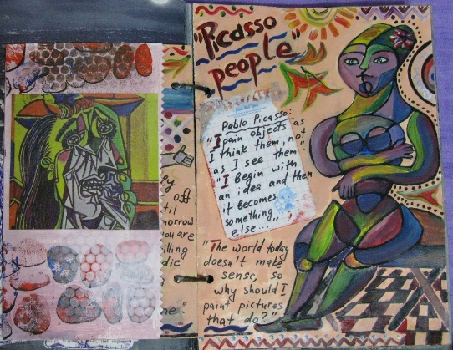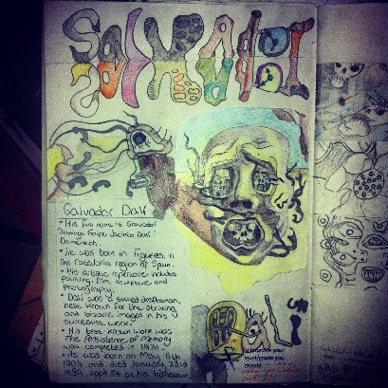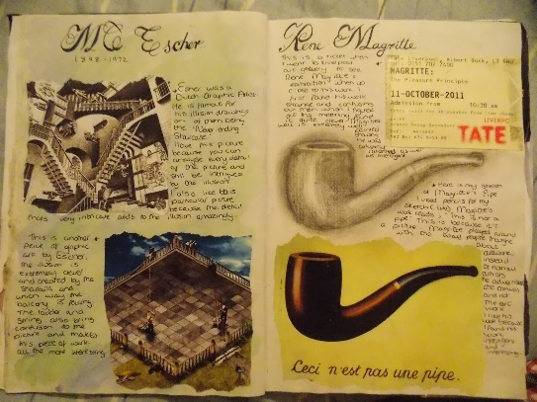

Objective: Students will research and illustrate an artist or artistic movement and create a visual journal.
A visual journal is a completed and interesting composition. It should be done IN your sketchbook and use a variety of art materials/mediums. For this project it is very similar to a magazine layout or scrapbook page. It should be both visually interesting as well as informative.
Requirements:
EVERYONE must have the following:
- Title (Bold and neat)
- AT LEAST 2 images of the artist’s recreated by the student (Nothing printed)
- Relevant and INTERESTING facts about the artist or movement.

Movements:
Post Impressionism, Fauvism, Cubism, Futurism, Constructivism, Dadaism, De Stijl, Surrealism, Italian Renaissance, Impressionism , Expressionism, Pop Art, Baroque, Gothic, Medieval, Mesopotamian, Op-Art, Prehistoric, Rococo, Folk Art, Bauhaus Design School

Artists:
Roy Lichtenstein, Willem de Kooning, Leonardo da Vinci, Claude Monet, Frank Stella, Henri Matisse, Rembrandt, Mary Cassatt, Georgia O'Keeffe, Michelangelo, Peter Paul Rubens, Edgar Degas, Caravaggio, Pierre-Auguste Renoir, Raphael, Paul Cezanne, Marc Chagall, Titian, Joan Miro, David Hockney, Gustav Klimt, Fernand Leger, Edward Hopper, Wassily Kandinsky, Jan Vermeer, Paul Klee, Edvard Munch, Goya , Edouard Manet, Howard Finster, Piet Mondrian, Peter Max, Bill Traylor, Joan Miro, George Rodrigue, Jasper Johns, Romare Bearden, M. C. Escher, Jacob Lawrence, Alexander Calder, Kathe Kollwitz, Kevin Cole, KAWS AKA Brian Donnelly, Eric Carle, David Siqueiros, Federico Correa, Roberto Matta, Amelia Peláez, Santiago Martinez Delgado, Camilo Mori, Gus Arriola, Salvador Dali
*Any other Artists must be approved by Mrs. Piercy

Standards:
VAHSDRMC1.a
Identifies artistic voice in a range of contemporary and past artists.
VAHSDRMC2.a
Uses sketchbook journal to research, explore, and invent artistic conventions to connect and express visual ideas.
VAHSDRCU1
Articulates ideas and universal themes from diverse cultures of the past and present.
VAHSDRPR4
Keeps a visual/verbal sketchbook journal, consistently throughout the course, to collect, develop and preserve ideas in order to produce works of art around themes of personal meaning.

